Lab 14: Batch Processing and Bulk Operations
Objective
To understand and implement Eager Loading and Explicit Loading for retrieving related data using Entity Framework Core.
Commands Used
dotnet run
Code
Program.cs
using Microsoft.EntityFrameworkCore;
using RetailInventory.Data;
using var context = new AppDbContext();
// Eager Loading
var products = context.Products
.Include(p => p.Category)
.ToList();
Console.WriteLine("Eager Loading");
Console.WriteLine("-------------");
foreach (var product in products)
{
Console.WriteLine($"Product : {product.Name}");
Console.WriteLine($"Price : {product.Price}");
Console.WriteLine($"Category : {product.Category.Name}");
Console.WriteLine();
}
// Explicit Loading
var firstProduct = context.Products.First();
context.Entry(firstProduct)
.Reference(p => p.Category)
.Load();
Console.WriteLine("Explicit Loading");
Console.WriteLine("----------------");
Console.WriteLine($"Product : {firstProduct.Name}");
Console.WriteLine($"Category : {firstProduct.Category.Name}");
Category.cs
using System.Collections.Generic;
namespace RetailInventory.Models
{
public class Category
{
public int Id { get; set; }
public string Name { get; set; }
public List<Product> Products { get; set; } = new List<Product>();
}
}Product.cs
namespace RetailInventory.Models
{
public class Product
{
public int Id { get; set; }
public string Name { get; set; }
public decimal Price { get; set; }
public int CategoryId { get; set; }
public Category Category { get; set; }
public int StockQuantity { get; set; }
}
}
AppDbContext.cs
using Microsoft.EntityFrameworkCore;
using RetailInventory.Models;
namespace RetailInventory.Data
{
public class AppDbContext : DbContext
{
public DbSet<Product> Products { get; set; }
public DbSet<Category> Categories { get; set; }
protected override void OnConfiguring(DbContextOptionsBuilder optionsBuilder)
{
optionsBuilder.UseSqlServer(
"Server=localhost\\SQLEXPRESS;Database=RetailDB;Trusted_Connection=True;TrustServerCertificate=True;");
}
protected override void OnModelCreating(ModelBuilder modelBuilder)
{
modelBuilder.Entity<Product>()
.Property(p => p.Price)
.HasPrecision(18, 2);
modelBuilder.Entity<Category>().HasData(
new Category { Id = 1, Name = "Electronics" },
new Category { Id = 2, Name = "Groceries" }
);
modelBuilder.Entity<Product>().HasData(
new Product
{
Id = 1,
Name = "Smartphone",
Price = 25000,
CategoryId = 1,
StockQuantity = 50
},
new Product
{
Id = 2,
Name = "Wheat Flour",
Price = 800,
CategoryId = 2,
StockQuantity = 100
}
);
}
}
}
Output
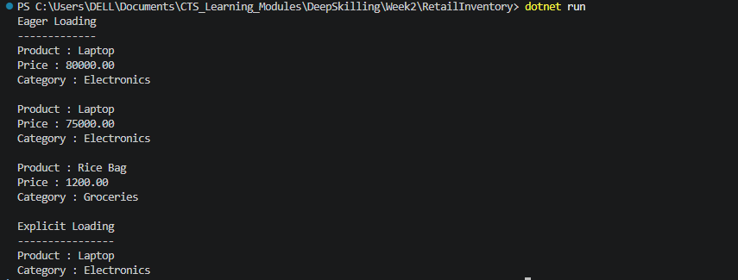
Result
The related category data was successfully retrieved using Eager Loading with Include() and Explicit Loading using Entry().Reference().Load(). This demonstrated different loading strategies available in Entity Framework Core.

